2520090067 J.Sahasra

ER DIAGRAMS
1. Problem
Draw of ER model for company considering the following constraints −
- In a company, an employee works on many projects which are controlled by one department.
- One employee supervises many employees.
- An employee has one or more dependents.
- One employee manages one department.
Solution:

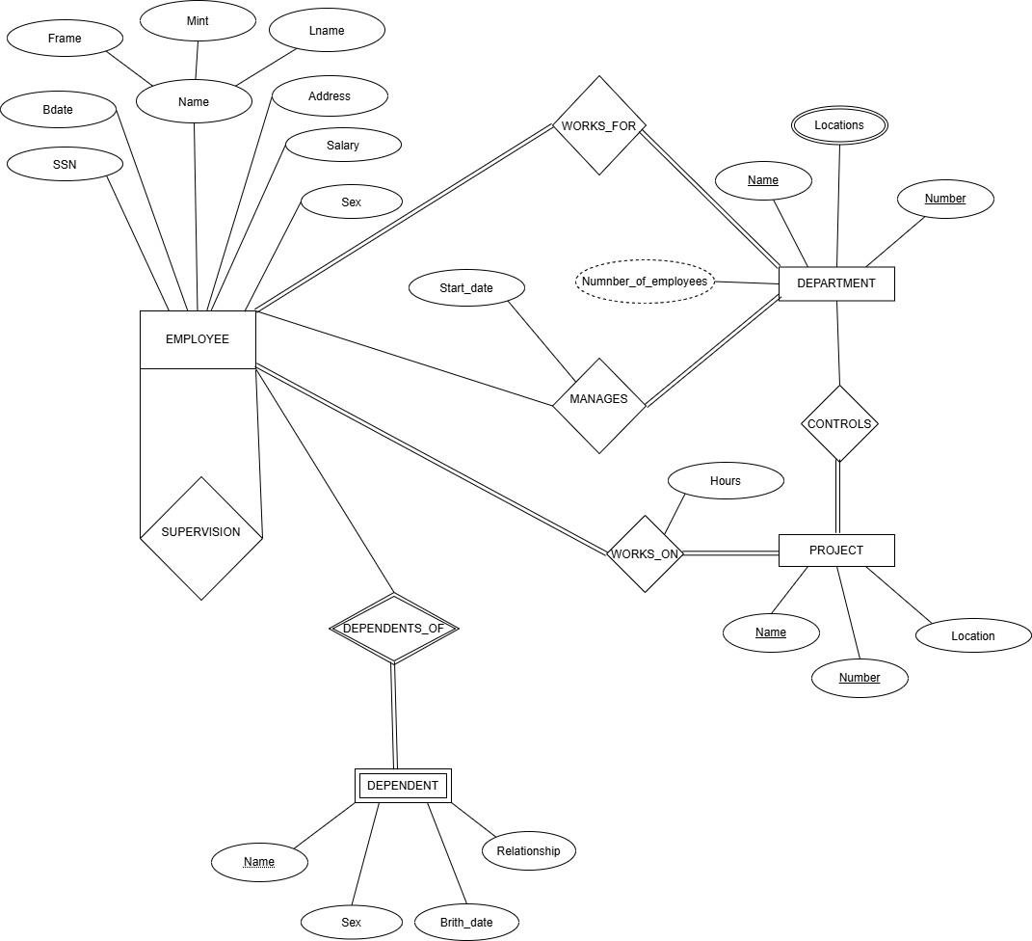
Draw an ER model for library management application considering the following constraints −
- In a library multiple students can enroll.
- Students can become a member by paying an appropriate fee.
- The books in the library are identified by a unique ID.
- Students can borrow multiple books from subscribed libraries.
Solution:

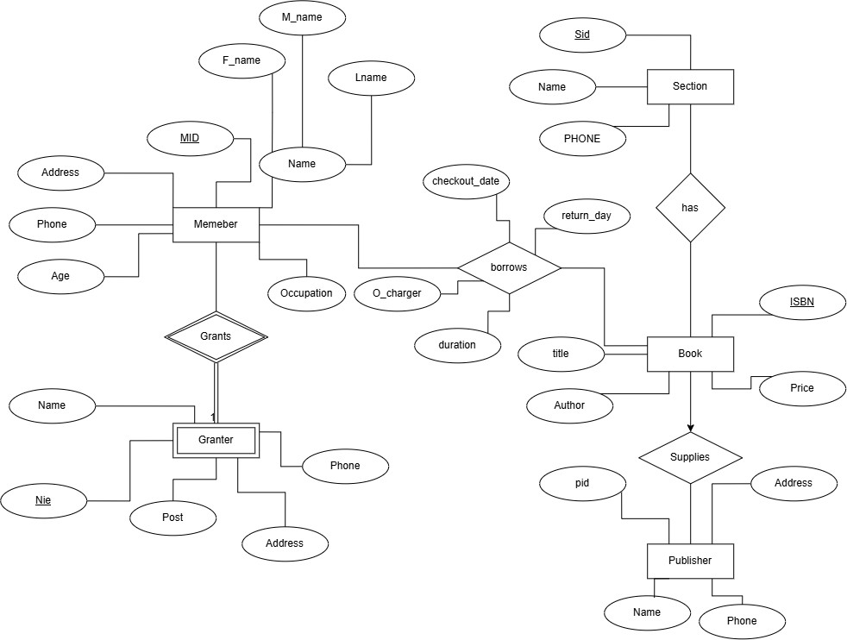
Draw an ER model of the Banking database application considering the following constraints −
- A bank has many entities.
- Each customer has multiple accounts.
- Multiple customers belong to a single branch.
- Single customer can borrow multiple loans.
- A branch has multiple employees.
Solution:
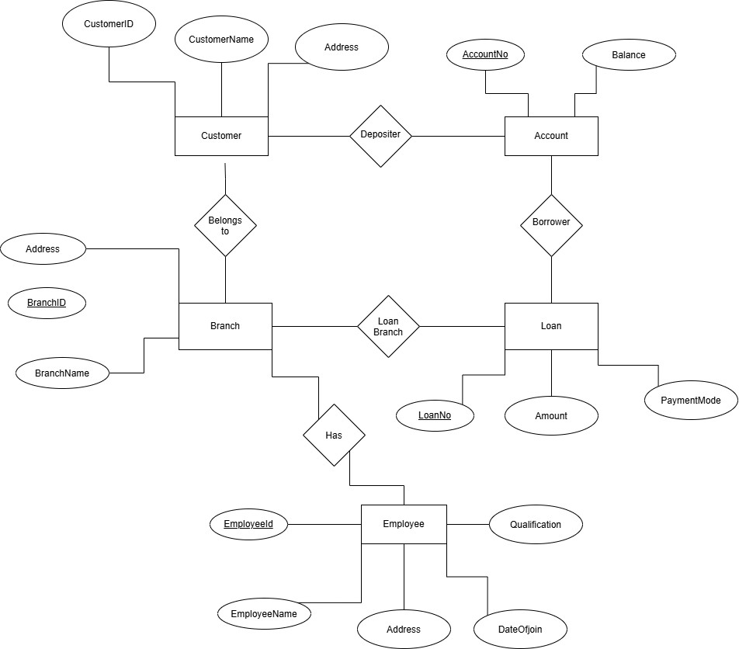
Drawing of ER model of university database application considering the constraints • A university has many departments.
- Each department has multiple instructors (one person is HOD). Here the HOD refers to the head of department.
- An instructor belongs to only one department.
- Each department offers multiple courses, each subject is taught by a single instructor.
- A student may enroll for many courses offered by different departments.
Solution:

